**Lab - 04**

**Trace File Analysis**

**Computer Networks**

**Program: MScIT Sem-2**

**Group ID : 28**

**Student Name Student ID**

Dev Adnani 202212012

Saif Saiyed 202212083

**202212083**

**2.2.1. Is your browser running HTTP version 1.0 or 1.1? What version of HTTP is the server running?**

Ans : Both browser and server are running HTTP version of 1.1



**2.2.2. What languages (if any) does your browser indicate that it can accept to the server?**

Ans : The browser indicates that it will accept en-US language to the server.

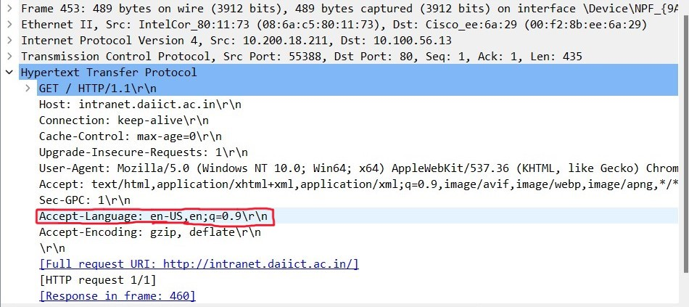

**2.2.3. What is the IP address of your computer?**

Ans : Source IP - 10.200.18.211

Destination IP - 10.100.56.13

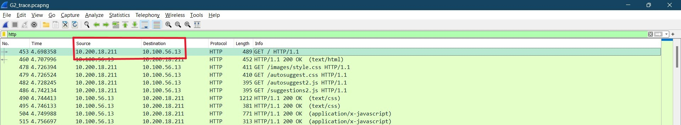

**2.2.4. What is the status code returned from the server to your browser?**

Ans : The status code returned was 200 OK.

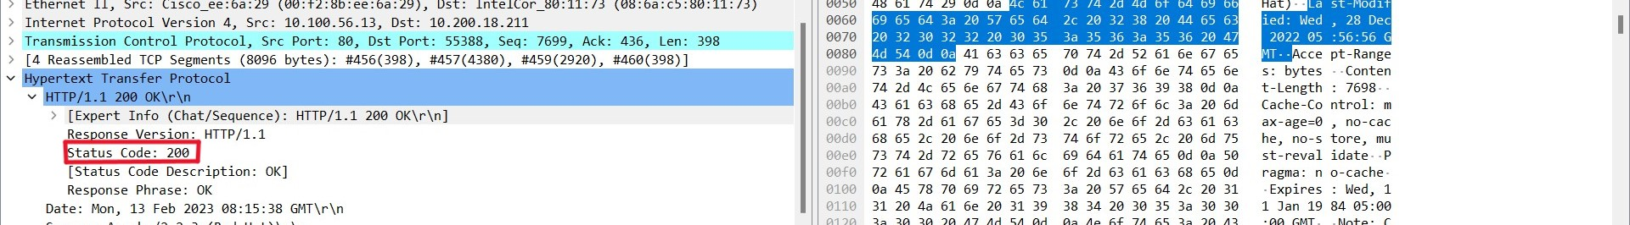

**2.2.5. When was the HTML file that you are retrieving last modified at the server?**

Ans : Last-Modified: Wed, 28 Dec 2022 05:56:56 GMT\r\n

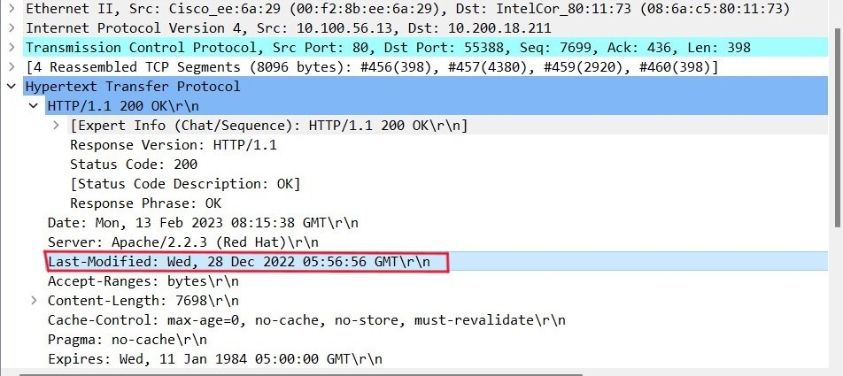

**2.2.6. How many bytes of content are being returned to your browser?**

Ans : 7698 bytes.

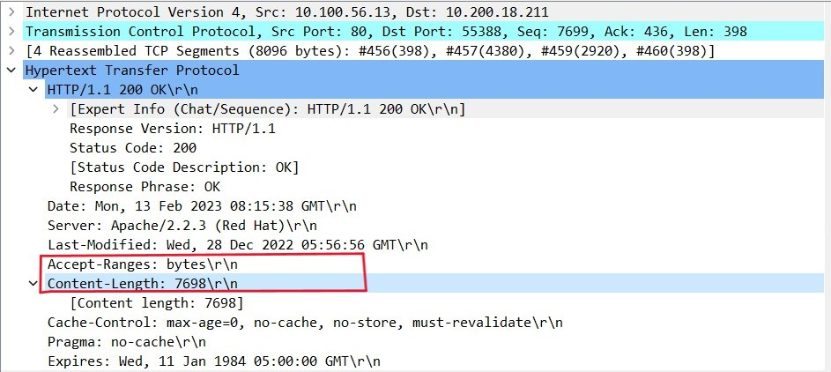

**3.2.1. Inspect the contents of the first HTTP GET request from your browser to the server. Do you see an “IF-MODIFIED-SINCE” line in the HTTP GET?**

Ans : No, we can’t see an “IF-MODIFIED-SINCE” line in the HTTP GET.

**3.2.2. Inspect the contents of the server response. Did the server explicitly return the contents of the file? How can you tell?**

Ans : The server returned the contents of the file. We can see it through the Line Based Text Data.

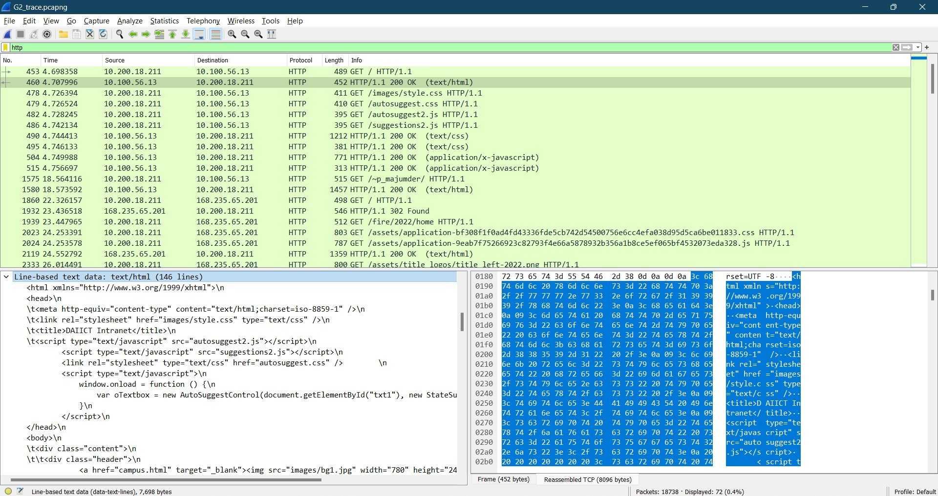

**3.3.3. Now inspect the contents of the second HTTP GET request from your browser to the server. Do you see an “IF-MODIFIED-SINCE:” line in the HTTP GET? If so, what information follows the “IF-MODIFIED-SINCE:” header?**

Ans : No, cant find IF-MODIFIED-SINCE.

**3.3.4. What is the HTTP status code and phrase returned from the server in response to this second HTTP GET? Did the server explicitly return the contents of the file? Explain.**

Ans : 200 OK and yes the server explicitly returned the contents of the file because of line based text data.

**4.2.1. How many HTTP GET request messages did your browser send?**

Ans : 36 GET requests.

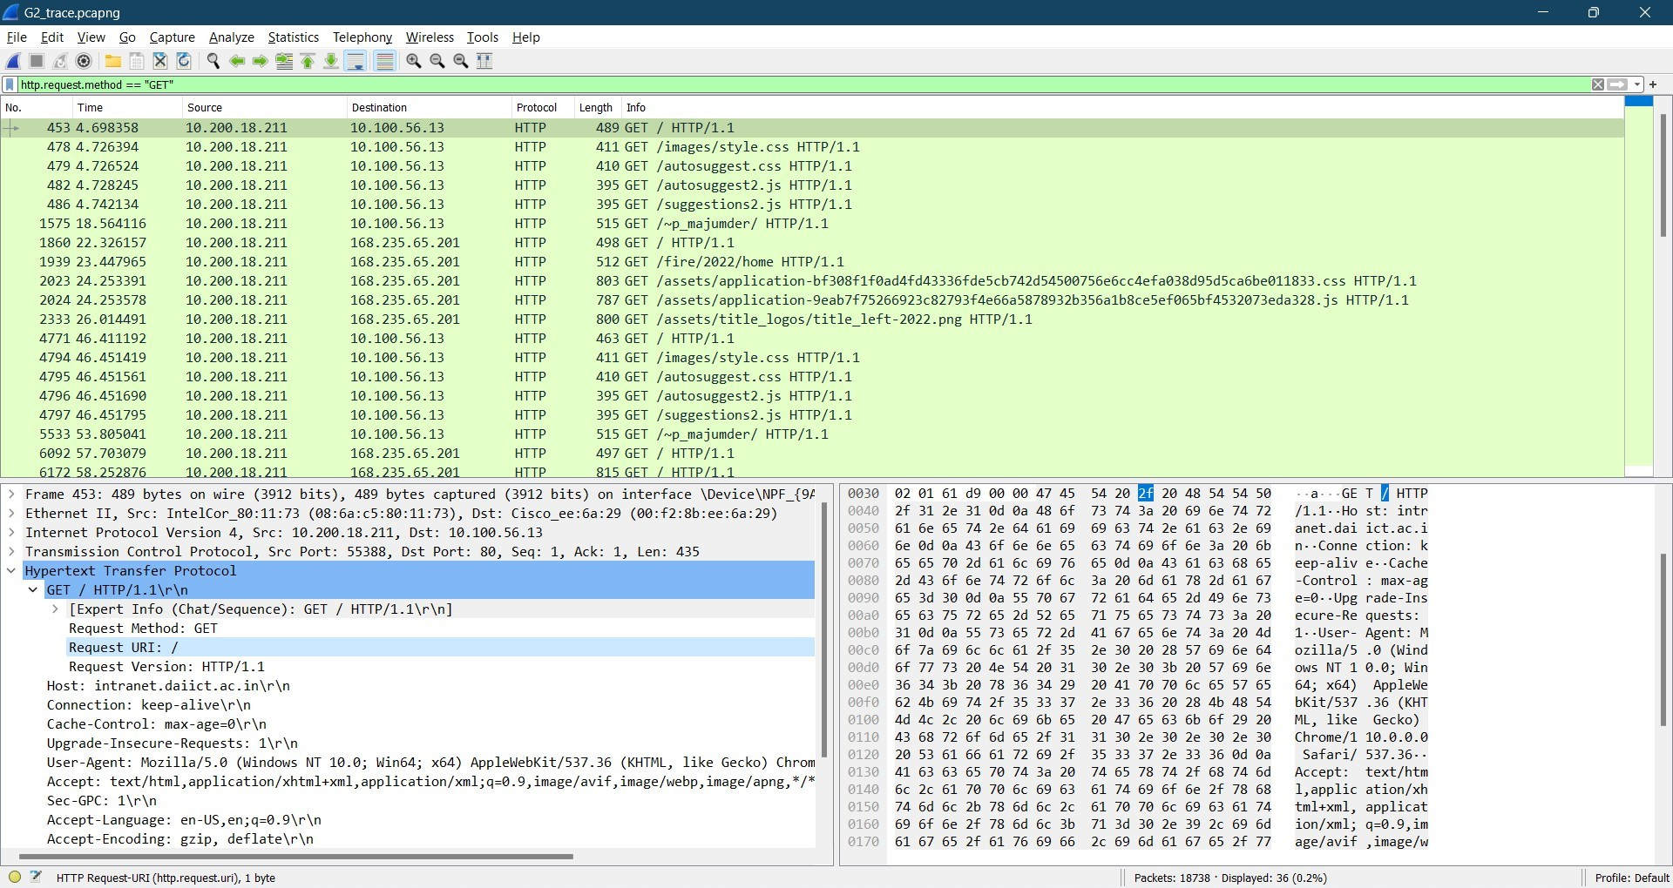

**4.2.2. How many data-containing TCP segments were needed to carry the single HTTP response?**

Ans : 4 data-containing TCP segments were needed to carry the single HTTP response.

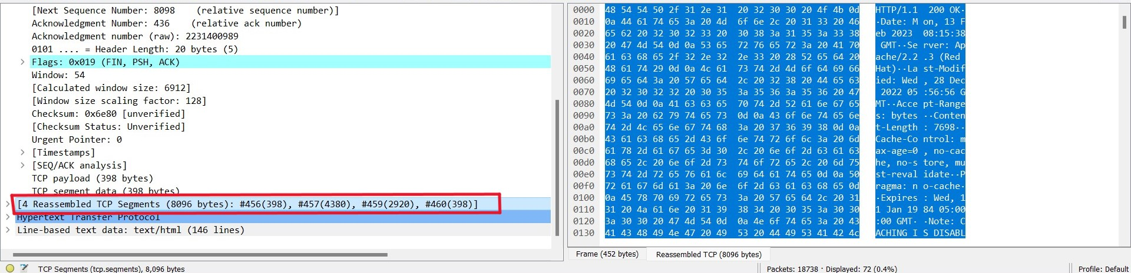

**4.2.3. What is the status code and phrase associated with the response to the HTTP GET request?**

Ans : The status code returned was 200 OK.



**5.2.1. How many HTTP GET request messages did your browser send? To which Internet addresses were these GET requests sent?**

Ans : 36 GET requests. They were sent to 10.100.56.13, 168.235.65.201.

**5.2.2. Can you tell whether your browser downloaded the two images serially, or whether they were downloaded from the two websites in parallel? Explain.**

Ans : No, the browser didn’t download the two images serially.

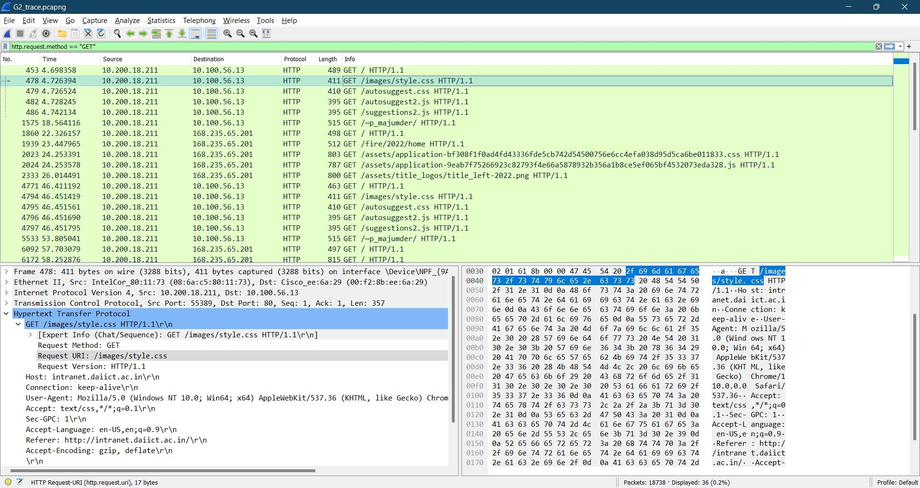

**6.2.1. What is the server’s response (status code and phrase) in response to the initial HTTP GET message from your browser?**

Ans : Status Code - 200; Phrase - OK.



**6.2.2. When your browser’s sends the HTTP GET message for the second time, what new field is included in the HTTP GET message?**

Ans : Nothing is included in the HTTP GET message for the second time.Just the referer is changed to http://intranet.daiict.ac.in.

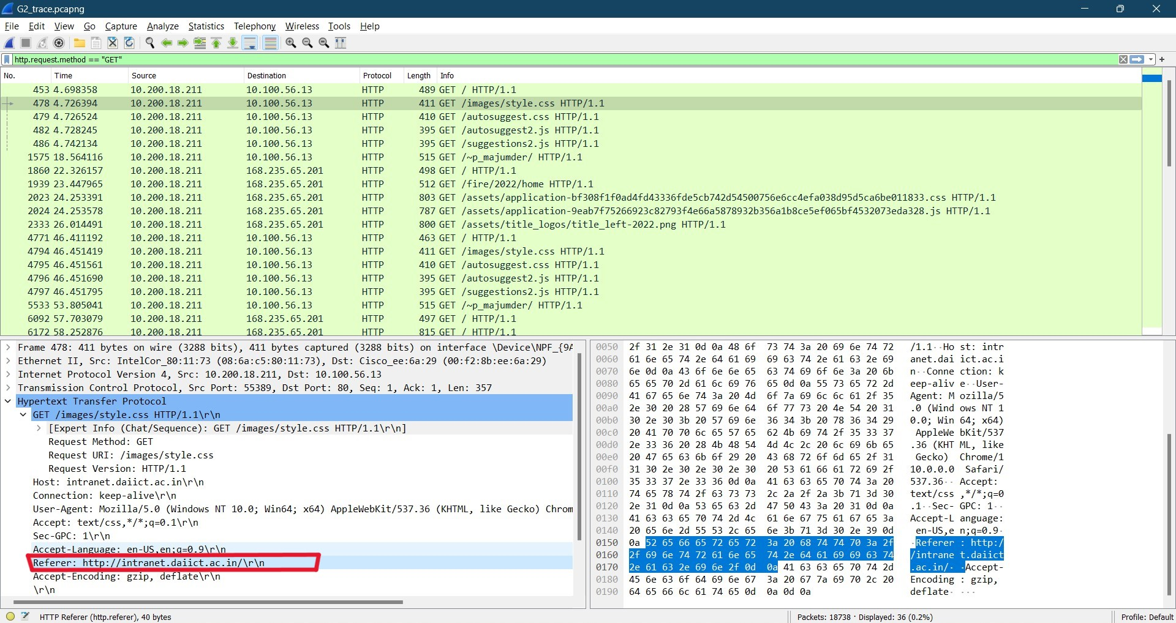

**202212012**

**2.2.1. Is your browser running HTTP version 1.0 or 1.1? What version of HTTP is the server running?**

Ans : Both browser and server are running HTTP version of 1.1



**2.2.2. What languages (if any) does your browser indicate that it can accept to the server?**

Ans : The browser indicates that it will accept en-US language to the server.



**2.2.3. What is the IP address of your computer?**

Ans : Source IP - 10.200.18.211

Destination IP - 10.100.56.13



**2.2.4. What is the status code returned from the server to your browser?**

Ans : The status code returned was 200 OK.



**2.2.5. When was the HTML file that you are retrieving last modified at the server?**

Ans : Last-Modified: Wed, 28 Dec 2022 05:56:56 GMT\r\n



**2.2.6. How many bytes of content are being returned to your browser?**

Ans : 7698 bytes.



**3.2.1. Inspect the contents of the first HTTP GET request from your browser to the server. Do you see an “IF-MODIFIED-SINCE” line in the HTTP GET?**

Ans : No, we can’t see an “IF-MODIFIED-SINCE” line in the HTTP GET.

**3.2.2. Inspect the contents of the server response. Did the server explicitly return the contents of the file? How can you tell?**

Ans : The server returned the contents of the file. We can see it through the Line Based Text Data.



**3.3.3. Now inspect the contents of the second HTTP GET request from your browser to the server. Do you see an “IF-MODIFIED-SINCE:” line in the HTTP GET? If so, what information follows the “IF-MODIFIED-SINCE:” header?**

Ans : No, cant find IF-MODIFIED-SINCE.

**3.3.4. What is the HTTP status code and phrase returned from the server in response to this second HTTP GET? Did the server explicitly return the contents of the file? Explain.**

Ans : 200 OK and yes the server explicitly returned the contents of the file because of line based text data.

**4.2.1. How many HTTP GET request messages did your browser send?**

Ans : 36 GET requests.



**4.2.2. How many data-containing TCP segments were needed to carry the single HTTP response?**

Ans : 4 data-containing TCP segments were needed to carry the single HTTP response.



**4.2.3. What is the status code and phrase associated with the response to the HTTP GET request?**

Ans : The status code returned was 200 OK.



**5.2.1. How many HTTP GET request messages did your browser send? To which Internet addresses were these GET requests sent?**

Ans : 36 GET requests. They were sent to 10.100.56.13, 168.235.65.201.

**5.2.2. Can you tell whether your browser downloaded the two images serially, or whether they were downloaded from the two websites in parallel? Explain.**

Ans : No, the browser didn’t download the two images serially.



**6.2.1. What is the server’s response (status code and phrase) in response to the initial HTTP GET message from your browser?**

Ans : Status Code - 200; Phrase - OK.



**6.2.2. When your browser’s sends the HTTP GET message for the second time, what new field is included in the HTTP GET message?**

Ans : Nothing is included in the HTTP GET message for the second time.Just the referer is changed to http://intranet.daiict.ac.in.

